What’s Stomata With You?


Leave Your Leaves Lesson 9 Student Worksheet

Pre-Lab Questions

- What are stomata?

- What is the function of stomata?

- What causes the guard cells to swell or shrink?

- Why do stomata open? Close?

Procedure:

- Get a leaf from the Tradescantia zebrina plant.
- Place it on your microscope BOTTOM SIDE UP under the lowest magnification. Adjust microscope until the cells are clear. Increase magnification if necessary.
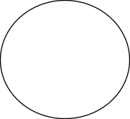

- Draw, color, and label what you see.

  - Epidermal Cells: Purple
  - Guard Cells- Green
  - Stomata- black or white

- Place the leaf on your miscroscope TOP SIDE UP under the lowest magnification. Adjust microscope until the cells are clear. Increase magnification if necessary.
- Which surface of the leaf has stomatal pores?
- Were the pores open or closed?
- Count the number of stomata on the underside of the leaf.
- How many are open? Closed?

Procedure 2:

- Get a leaf that has been in the dark overnight.
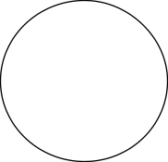

- Observe it through the microscope, bottom side up.
- Draw, color, and label what you see.

  - Epidermal Cells: Purple
  - Guard Cells- Green
  - Stomata- black or white
- Count the total number of stomata.
- How many are open? Closed?

Analysis and Conclusions:

- What percent of the stomata in the leaves in procedure 1 were open?

- What percent of the stomata on the leaves in procedure 2 were open?

- What conclusion can you draw from your data above? Be specific.

- What evolutionary advantage might there be to plants having more stomata on the underside of their leaves?

- What evolutionary advantage might there be to plants closing their stomata at night?

- What do you think might happen to a plant’s stomata in an extremely humid environment and why?

- What other adaptations have some plants acquired that have helped them to increase their survival?

